Creating a Microsoft Power BI

Desktop Solution

# Overview

## The estimated time to complete the lab is 80 minutes

In this lab, you will create a Power BI Desktop solution to enable the reporting and analysis of Wind Power Generator. This will involve creating Power BI Desktop queries that source data from SQL Server and a CSV file.

You will then create one report pages consisting of various data visualizations.

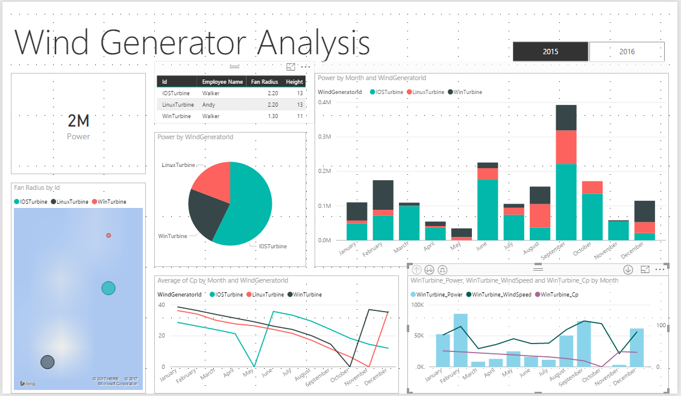

You will learn how to:

* Create a Power BI Desktop solution
* Create queries based on a variety of data sources
* Prepare a model for reporting
* Create an interactive dashboard layout consisting of several data visualizations
* Publish Power BI Desktop solution to Power BI Service

# Stage 1

## Creating a Power BI Desktop File

In this task, you will create a Power BI file.

1. To open the Power BI Desktop, on the taskbar, click the **Microsoft Power BI Desktop** shortcut.

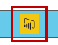

1. To close the startup screen, at the top-right corner, click **X**.



1. To save the file, click the **File** tab, and then select **Save As**.
2. In the **Save As** window, navigate to the **~\06-HOL** folder.
3. In the **File Name** box, enter **Wind Power Generator Analysis**.
4. Click **Save**.

## Importing Data from Microsoft Azure SQL Server

In this task, you will create a query to retrieve sales order data from the **PowerBI** Microsoft Azure SQL Server database.

1. On the **Home** ribbon, from inside the **External Data** group, click the **Get Data** dropdown, and then select **More**.

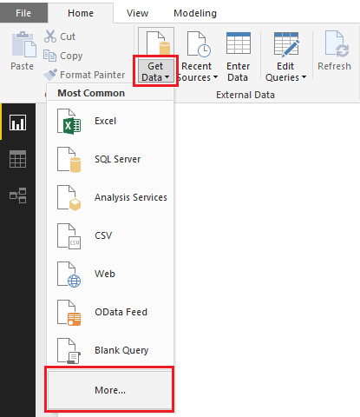

1. Click **Azure** in left side and click **Microsoft Azure SQL database** in right side, then click **connect.**

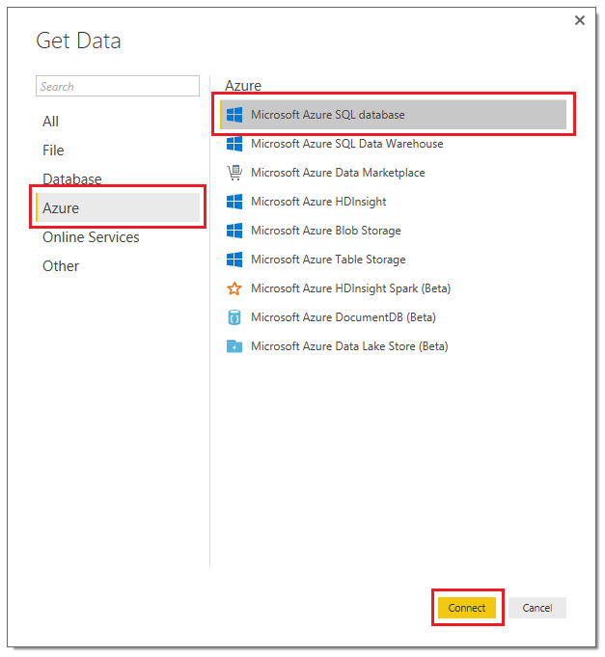

1. In the **SQL Server Database** dialog window, in the **Server** box, enter **andy-workshop.database.windows.net**.
2. In the **Database** box, enter **WindPower**.

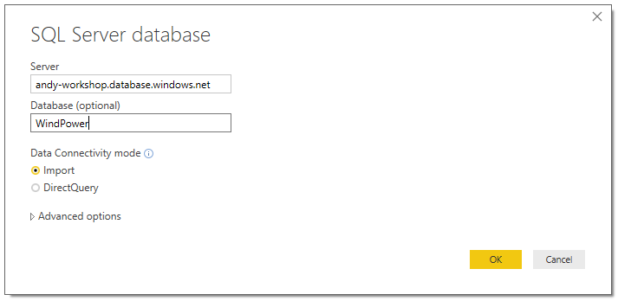

1. Click **OK**.
2. When prompted to authenticate, click database in left side, in the **Username** box, enter **readonlylogin,** in the Password box, enter **!QAZ2wsx3edca**, then click **connect**.

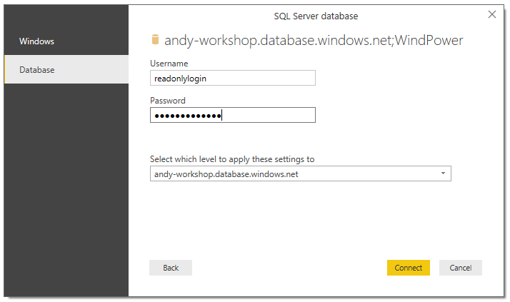

1. click **Connect**.
2. When prompted to confirm the use of an unencrypted connection, click **OK**.
3. In the **Navigator** dialog window, check the **Message and WindGenerator** table.

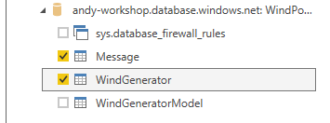

1. To develop the query, click **Edit**.



1. Notice that the **Query Editor** window opens, and that this window has its own ribbon.

*This window is used to define query steps to transform data, and to preview the query result.*

1. In the Query pane, select **WindGenerator**.

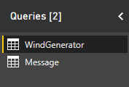

1. In the data pane (the large pane containing the data grid), notice that the **WindGeneratorModel** columns contain **Value** links, enabling the introduction of columns from the related tables.

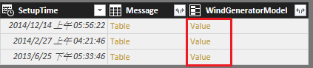

*These columns were added automatically because the* ***ModelName*** *columns of the* ***WindGenerator*** *table are foreign key columns.*

1. To introduce columns from the **WindGeneratorModel** table, in the **Employee** column header, click **Expand**.



1. Uncheck **(Select All Columns)**, and then check only the following two columns.

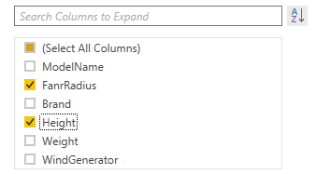

1. Uncheck the **Use Original Column Name as Prefix** checkbox.

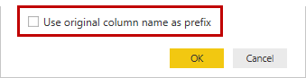

1. Click **OK**.
2. To remove unnecessary columns, first select the **SetupTime** column header, and then while pressing the **Control** key, select also the **Message** column headers.
3. Right-click the column selection, and then select **Remove Columns**.

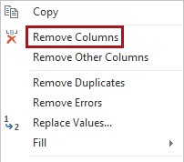

1. To rename the column, right-click the **FanrRadius** header column, and then select **Rename**.
2. Modify the name to **Fan Radius**, and then press Enter.
3. To close the Query Editor window, on the File menu, select Close.

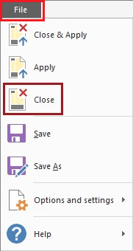

23. In Power BI Desktop, notice the warning describing that the new queries have not been applied.



24. Click **Apply Changes**.

*Applying changes will load data and detect relationships. Data will only be loaded if the data has not already been loaded, or a query definition has been changed.*

## Adding Report Decoration

In this task, you will add a text box to the default report page.

1. Switch to Report view.



*The blank area is the report page canvas.*

1. At the bottom left corner, notice the page navigation control.

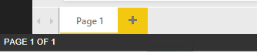

1. To name the page, double-click **Page 1**.
2. Replace the text with **Summary**, and then press **Enter**.

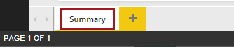

1. On the **View** ribbon, check **Show gridlines** to help us arrange layout.

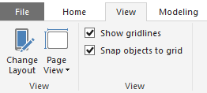

1. To insert a text box, on the **Home** ribbon, from inside the **Insert** group, click **Text Box**.

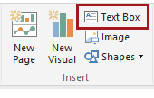

1. Inside the text box, enter **Wind Generator Analysis**.
2. Select the entire text, and then use the text format bar to increase the font size to **66**.
3. Resize the text box to a smaller size, and then reposition it as follows.

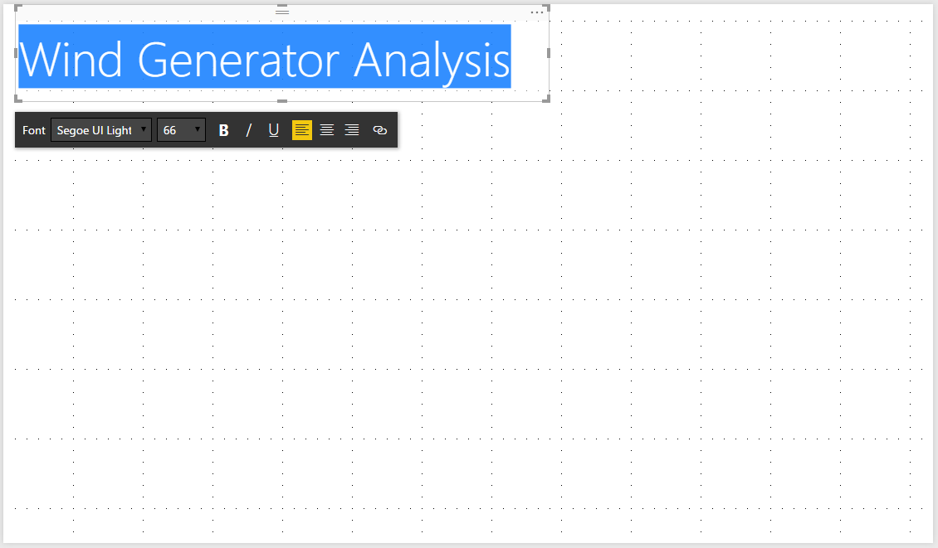

## Creating a Slicer

In this task, you will create a slicer to enable the report user to interact and filter by year.

1. In the **Fields** pane, notice that only two tables are available.
2. To create a visualization based on a field, in the **Fields** pane, expand the **Message** table, and then drag the **LocalTime** field and drop it on a blank area of the canvas.

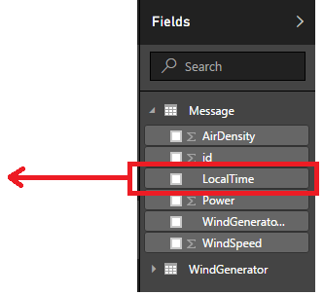

1. To switch the visualization to a slicer, in the Visualizations pane, click the Slicer icon. 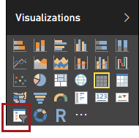
2. To change the **LocalTime** value, in the Field well, for the **LocalTime** field, click ▼.

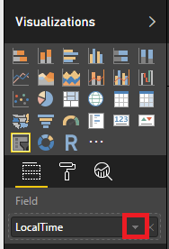 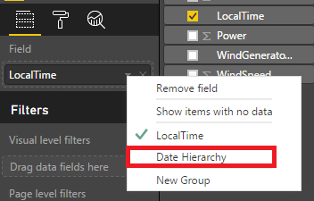

1. To modify the visualization style, switch to Format view.

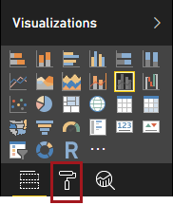

1. Turn off **Header**.

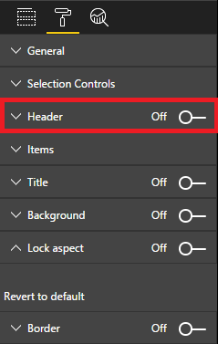

1. Expand **General** and switch **Orientation** to **Horizontal**

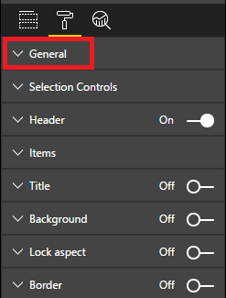 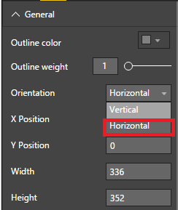

1. Expand **Selection Controls**, turn off **Single Select.**

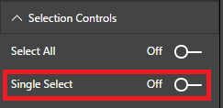

1. Resize the slicer, and then reposition it as follows.

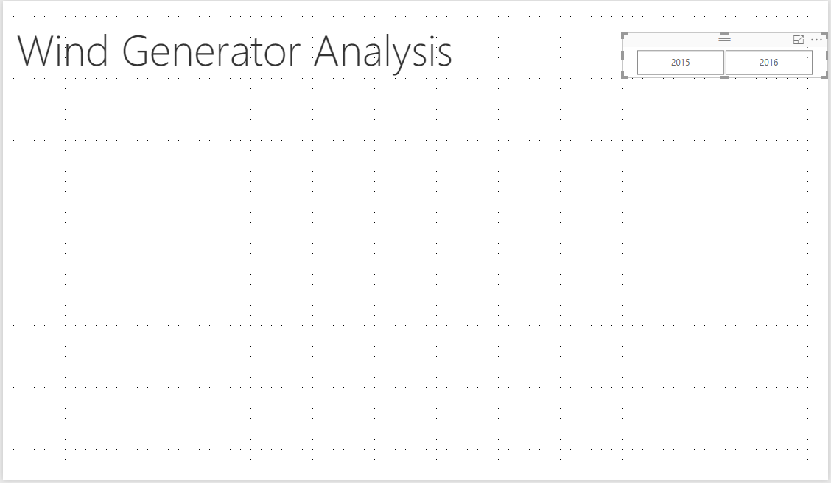

1. In the slicer, select **2015**.

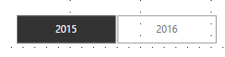

## Creating a Card

In this task, you will create a card visualization to display total power Wind Generator generate.

1. In the **Fields** pane, from inside the **Message** table, drag the **Power** field and drop it on a blank area of the canvas.
2. To switch the visualization to a card, in the Visualizations pane, click the Card icon.

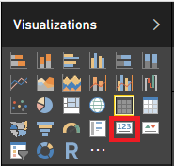

1. Resize, and reposition, the visualization as follows.

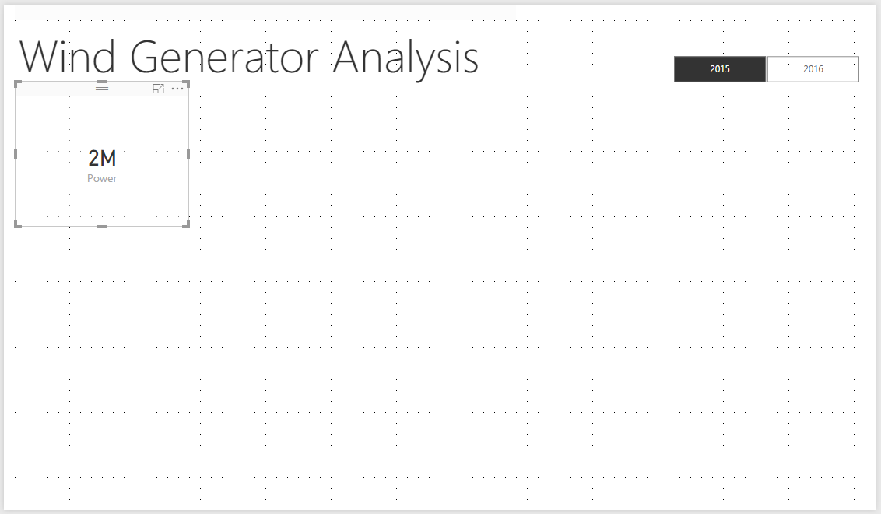

## Creating a Map

In this task, you will create a map to display Wind Power Generator location and generator scale.

1. Switch to Report view



1. In the **Fields** pane, from inside the **WinGenerator** table, create a new visualization based on the **Latitude** and **Longitude** field.

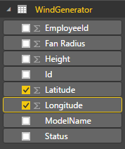

1. Drag **Id** to **Legend** column and **Fan Radius** to **Size** column**.**

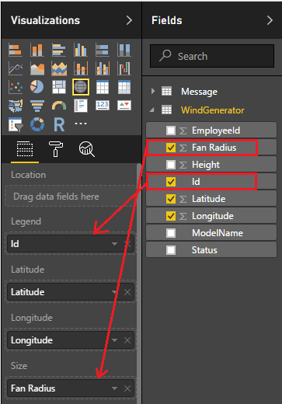

1. To set the **Default Count** property of **Fan Radius** to **Sum**

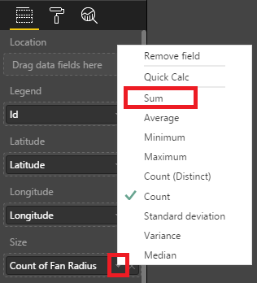.

1. Resize, and reposition, the visualization as follows.

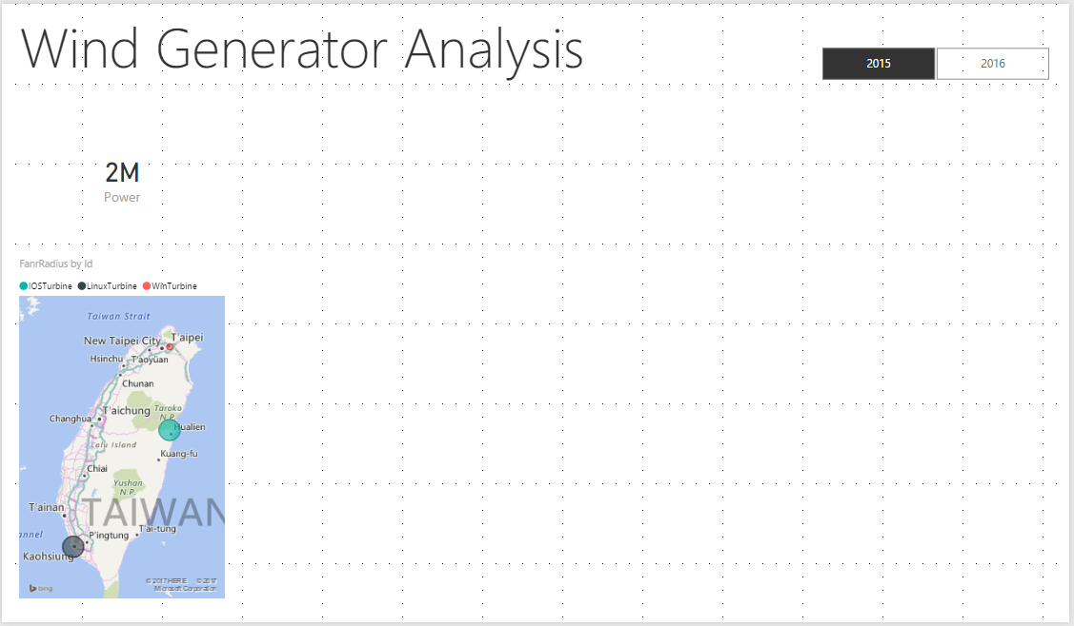

# Stage 2

## Importing Data from a CSV File

In this task, you will create a query from a CSV file to retrieve Employee information.

1. To switch to Relationships view, at the left side, click **Relationships**.



1. Reposition and resize the tables to enable a clearer understanding of the model.

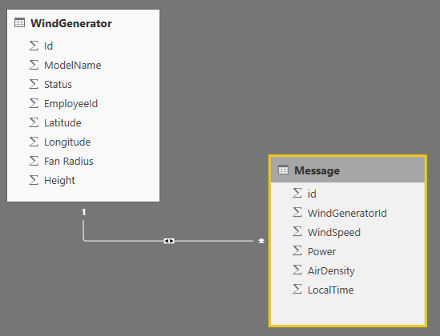

1. On the **Home** ribbon, from inside the **External Data** group, click the **Get Data** dropdown, and then select **CSV**.
2. In the **Open** window, navigate to the **~\06-HOL**  folder.
3. Select the **Employee.csv** file, and then click **Edit**.

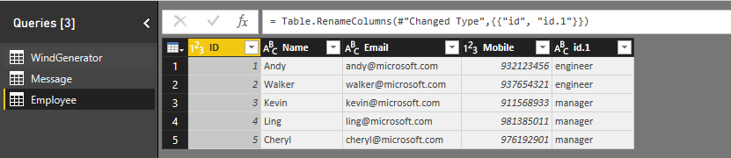

1. In the **Queries** pane (located at the left), select the **WindGenerator** query.

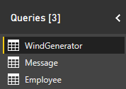

1. On the **Home** ribbon, from inside the **Combine** group, click **Merge Queries**.



1. In the **Merge** dialog window, in the data grid, select the **EmployeeId** column header.
2. In the dropdown list, select the **Employee** query.
3. In the lower data grid, select the **Id** column header.

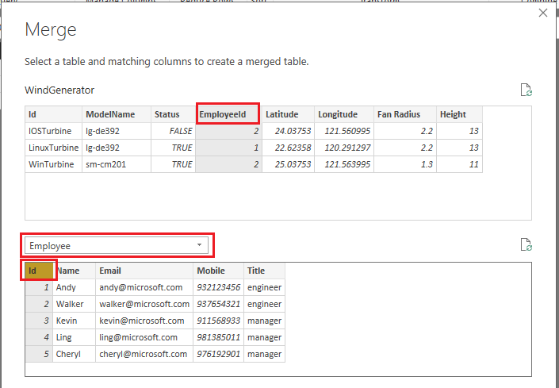

1. In the **Privacy Levels** dialog window, for the **andy-workshop.database.windows.net** data connection, in the adjacent dropdown list, select **Organizational**. Configure the privacy level for the **d:\** file location to **Organizational** also.

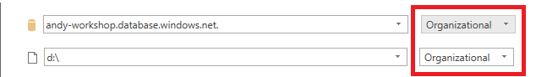

1. Click **Save**.

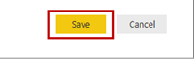

1. Located at the bottom-left corner of the **Merge** dialog window, notice that all rows have matched.

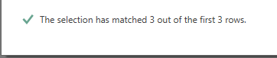

1. Click **OK**.
2. In the data pane, at the end of the columns, notice the addition of a new column named **NewColumn**.
3. Expand the **NewColumn** column to include only the **Name** column.

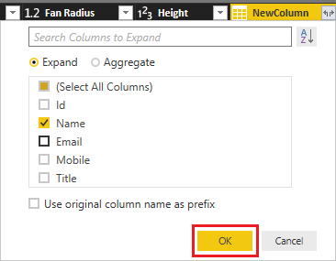

1. To rename the column, right-click the **Name** header column, and then select **Rename**.
2. Modify the name to **Employee Name**, and then press Enter.
3. To close the Query Editor window, on the File menu, select Close&Apply.

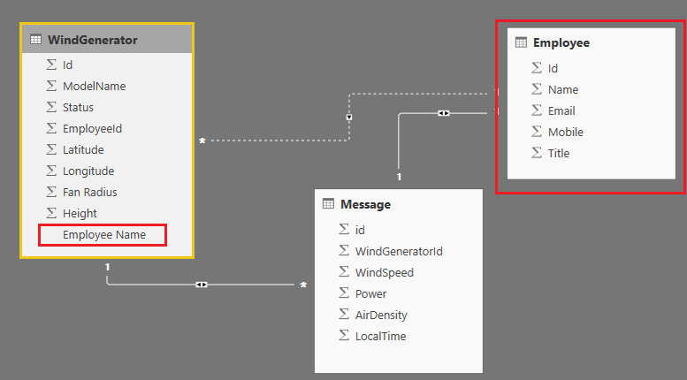

1. Right-Click table **Employee** header and click **Hide in Report View,** notice that hidden tables and fields are grayed out.

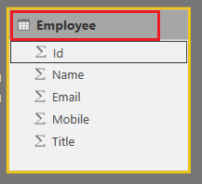 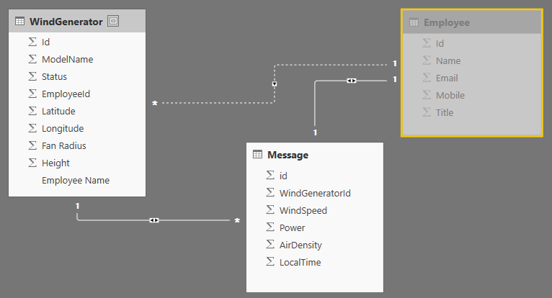

## Creating Tables

In this task, you will create a table to display wind generator basic information and who are responsible for [maintenance](https://tw.dictionary.yahoo.com/dictionary?p=maintenance).

1. Switch to Report view



1. In the **Fields** pane, from inside the **WindGenerator** table, drag the **Id** field and drop it on a blank area of the canvas.
2. Add the **Employee Name, FanRadius, Height** field to the new visualization.

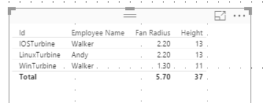

1. In the Field well, for the **FanrRadius** field, click ▼.

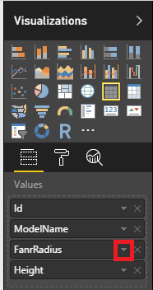

1. Switch value to **Don’t summarize.**

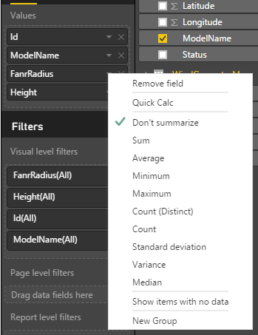

1. In the Field well, for the **Height** field, click ▼.

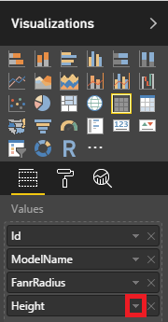

1. Switch value to **Don’t summarize.**



1. Resize, and reposition, the visualization as follows.

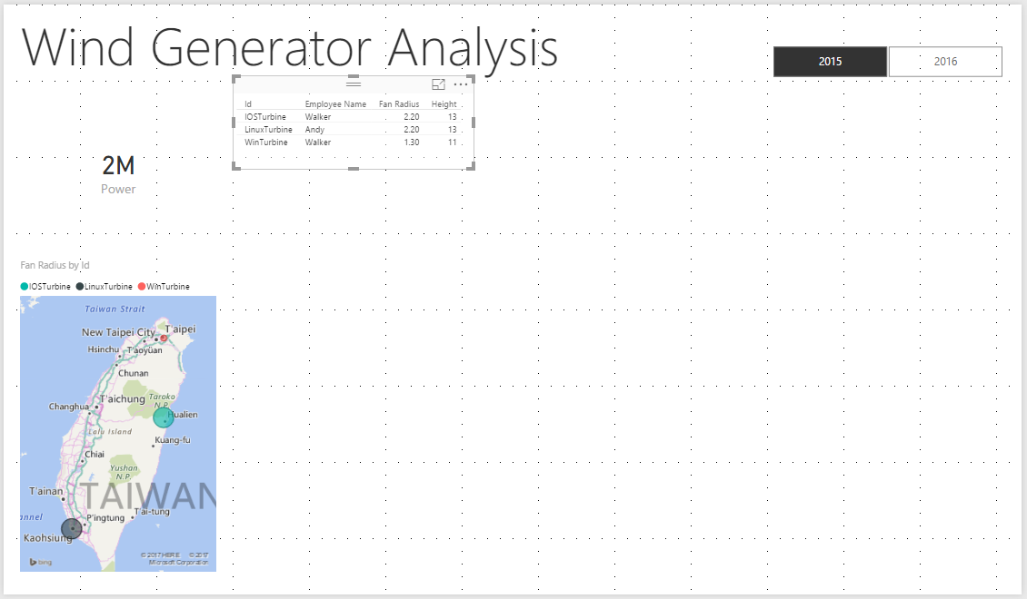

## Creating a Pie Chart

In this task, you will create a pie chart to display the proportion of power generated by different Wind Power Generator.

1. To create a visualization based on a field, in the Fields pane, expand the **Message** table, and then drag the **Power** field and drop it on a blank area of the canvas.
2. To switch the visualization to a pie chart, in the Visualizations pane, click the Pie chart icon.

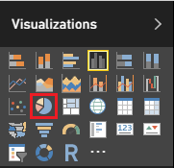

1. Drag the **WindGeneratorId** to Legend column.

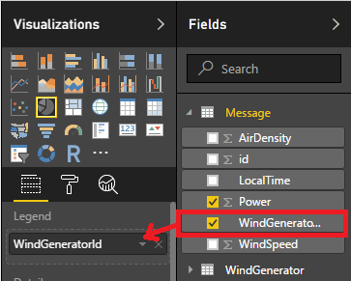

1. Resize, and reposition, the visualization as follows.

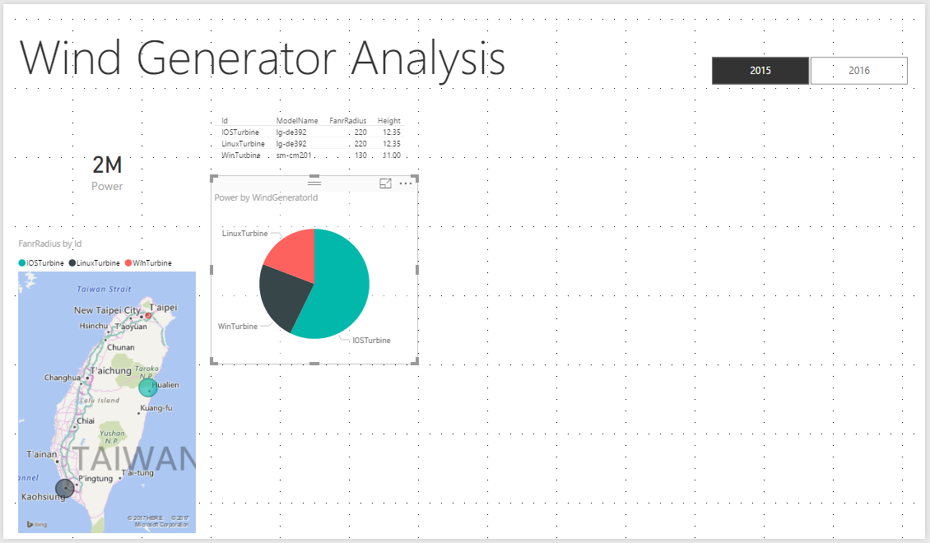

## Creating a Stacked Column Chart

In this task, you will create a stacked column chart to display the proportion of power generated by different Wind Power Generator by month.

1. To create a visualization based on a field, in the Fields pane, expand the **Message** table, and then drag the **Power** field and drop it on a blank area of the canvas.
2. To switch the visualization to a pie chart, in the Visualizations pane, click the Pie chart icon.

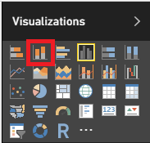

1. Drag the **LocalTime** to **Axis** column, then remove **Year** and **Quarter** field.

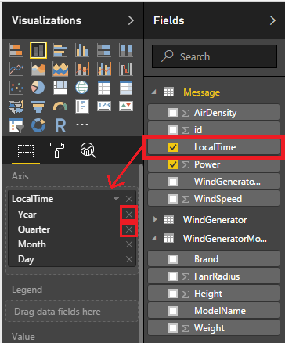

1. Drag the **WindGeneratorId** to Legend column.

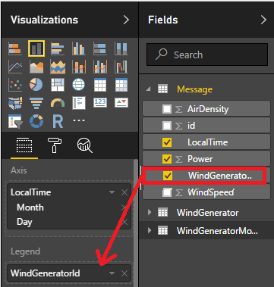

1. To modify the sort order, first click the ellipsis located at the top-right corner of the visualization.
2. Select **Sort by Month**.

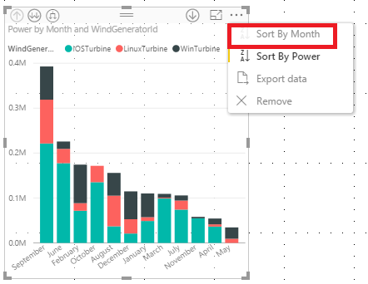

1. To sort by month ascending, click the ellipsis again, and then click **Sort by Month** again.
2. Resize, and reposition, the visualization as follows.

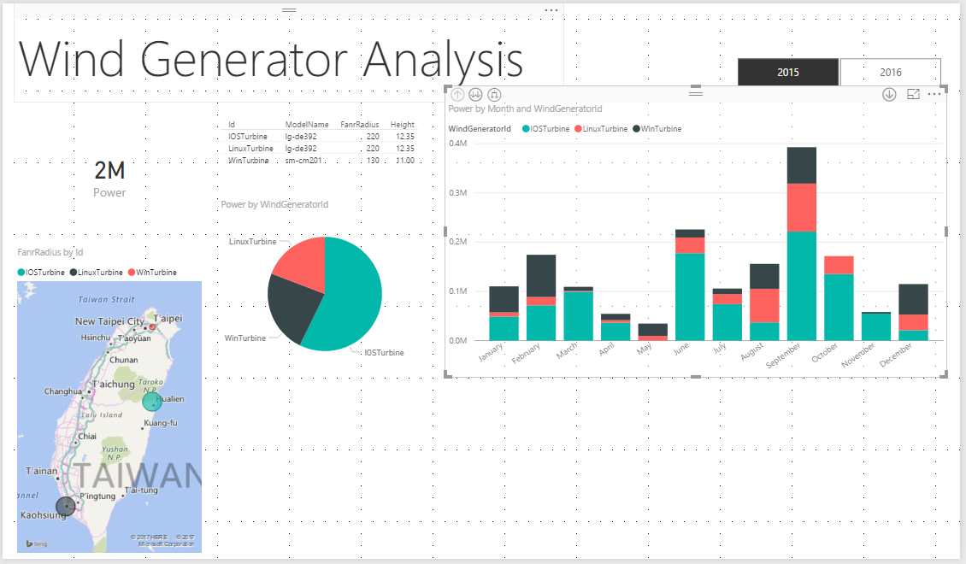

# Stage 3

## Creating a New Column

In this task, you will create a new column **Cp** in table **Message** to display the conversion rate of message.

1. On the **Home** ribbon, from inside the **External Data** group, click **Edit Queries**.

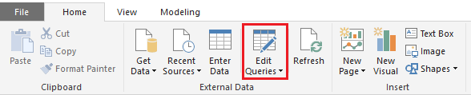

1. In the **Queries** pane (located at the left), select the **Message** query.

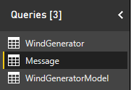

1. To introduce columns from the **WindGenerator** table, in the **Employee** column header, click **Expand**.



1. Uncheck **(Select All Columns)**, and then check only the following column.

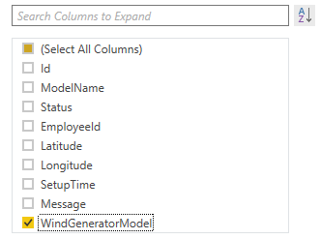

1. Uncheck the **Use Original Column Name as Prefix** checkbox.



1. Click **OK**.
2. To introduce columns from the **WindGeneratorModel** table, in the **WindGeneratorModel** column header, click **Expand**.



1. Uncheck **(Select All Columns)**, and then check only the following column.

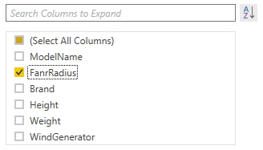

1. Uncheck the **Use Original Column Name as Prefix** checkbox.



1. Click **OK**.
2. On the **Add Conlum** ribbon, from inside the **General** group, click **Custom Column**.

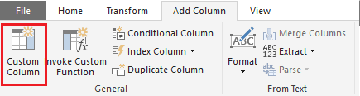

1. To set value of new column name by **Cp**, and Custom column formula by **([Power] / ( (0.5 * (0.5 * 3.1416 * [FanrRadius] * [FanrRadius]) * [WindSpeed] * [WindSpeed] * [WindSpeed] * [AirDensity]) / 10000)) * 100**, then click ok.

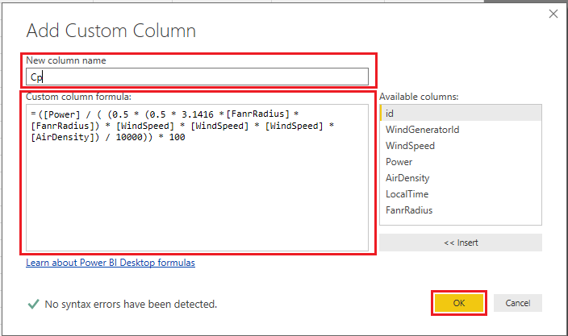

1. The result as below picture

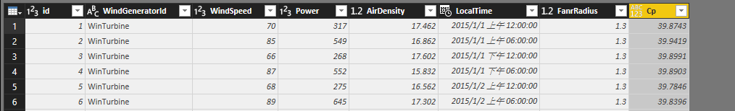

1. On the **Home** ribbon, from inside the **Transform** group, click **Data Type**.

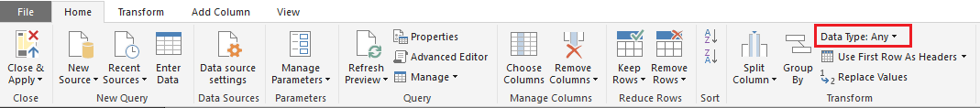

1. Switch Data Type to **decimal Number**.

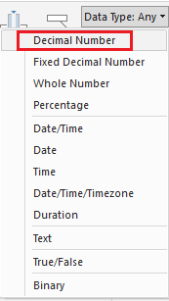

1. Close the Query Editor window, on the File menu, select Close&Apply.

## Creating a Line Chart

In this task, you will create a line chart to display the average Cp of different Wind Power Generator by month.

1. To create a visualization based on a field, in the Fields pane, expand the **Message** table, and then drag the **Cp** field and drop it on a blank area of the canvas.
2. To switch the visualization to a line chart, in the Visualizations pane, click the line chart icon.

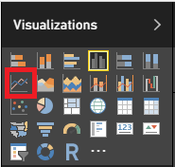

1. Drag the **WindGeneratorId** to Legend column.

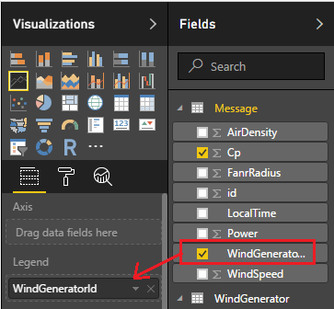

1. Drag the **LocalTime** to **Axis** column, then remove **Year** and **Quarter** field.

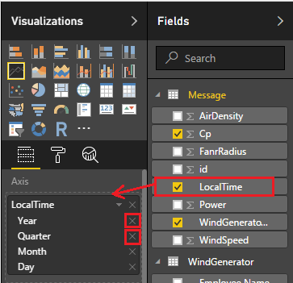

1. To set the **Default Summarization** property of **Cp** to **Average**.

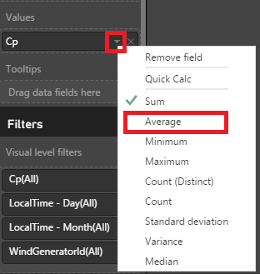

1. To modify the sort order, first click the ellipsis located at the top-right corner of the visualization.
2. Select **Sort by Month**.

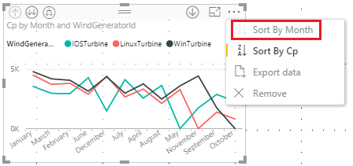

1. To sort by month ascending, click the ellipsis again, and then click **Sort by Month** again.
2. Resize, and reposition, the visualization as follows.

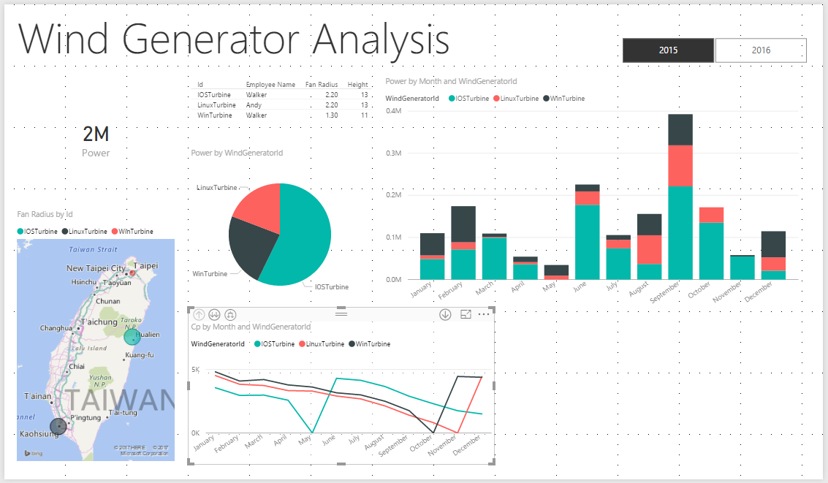

## Creating Measures

In this task, you will create three new measures to retrieve the detail of message which generated by WinTurbin.

1. In the **Fields** pane, right-click the **Message** table, and then select **New Measure**.
2. In the formula bar, replace the word **Measure** with **WinTurbine_Power**.
3. On the right side of the equals sign, enter the following formula.

|  |
| --- |
| **DAX** |
| WinTurbine_Power = CALCULATE(SUM(Message[Power]), Message[WindGeneratorId]="WinTurbine") |

1. In the **Fields** pane, right-click the **Message** table, and then select **New Measure**.
2. In the formula bar, replace the word **Measure** with **WinTurbine_Cp**.
3. On the right side of the equals sign, enter the following formula.

|  |
| --- |
| **DAX** |
| WinTurbine_Cp = CALCULATE(AVERAGE(Message[Cp]), Message[WindGeneratorId]="WinTurbine") |

1. In the **Fields** pane, right-click the **Message** table, and then select **New Measure**.
2. In the formula bar, replace the word **Measure** with **WinTurbine_WindSpeed**.
3. On the right side of the equals sign, enter the following formula.

|  |
| --- |
| **DAX** |
| WinTurbine_WindSpeed = CALCULATE(AVERAGE(Message[WindSpeed]), Message[WindGeneratorId]="WinTurbine") |

## Creating a Line and Stacked Column Chart

In this task, you will create a line and stacked column chart to display the detail of message generated by WinTurbin.

1. To create a visualization based on a field, in the Fields pane, expand the **Message** table, and then drag the **WindTurbine_Power** field and drop it on a blank area of the canvas.
2. To switch the visualization to a line and stacked column chart, in the Visualizations pane, click the line and stacked column chart.

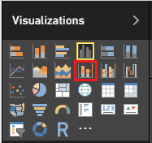

1. Drag the **LocalTime** to **Axis** column, then remove **Year** and **Quarter** field.

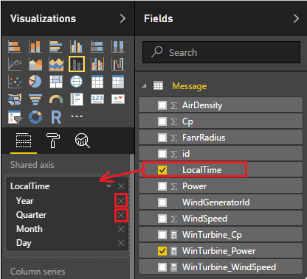

1. Drag the **WinTurbine_Cp** and **WinTurbine_WindSpeed** to Line values.

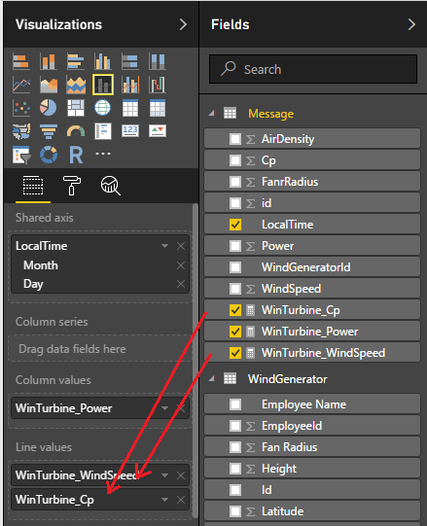

1. To modify the sort order, first click the ellipsis located at the top-right corner of the visualization.
2. Select **Sort by Month**.

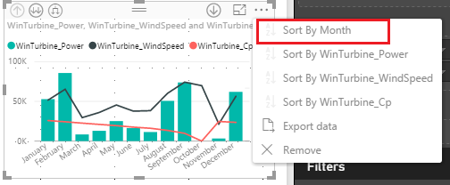

1. To sort by month ascending, click the ellipsis again, and then click **Sort by Month** again.
2. To modify the data style, switch to Format view.



1. Expand **Data colors** and change the color to identify different data.

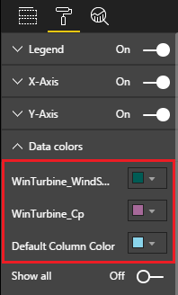

1. Resize, and reposition, the visualization as follows.

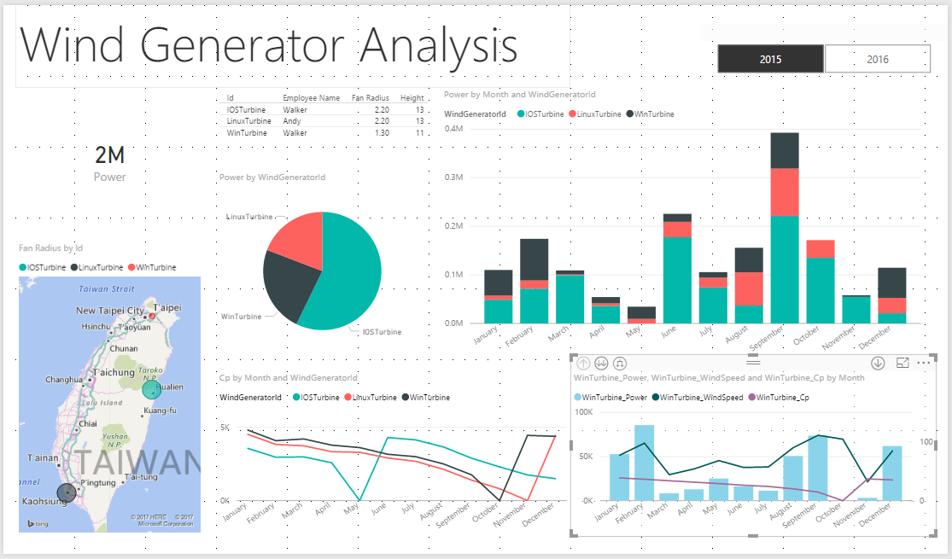

## Beautifying Layout (Optional)

1. Click card in layout.

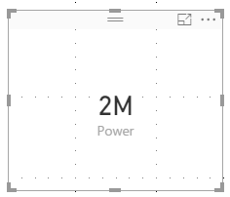

1. Switch to Format view.



1. Turn on Border and click left region in red box as below picture show

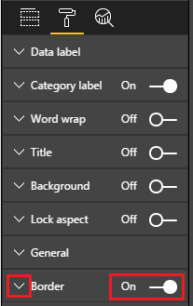

1. Change the color as below picture show

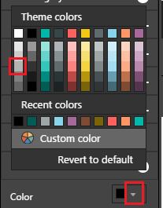

1. Repeat above step to other visual.

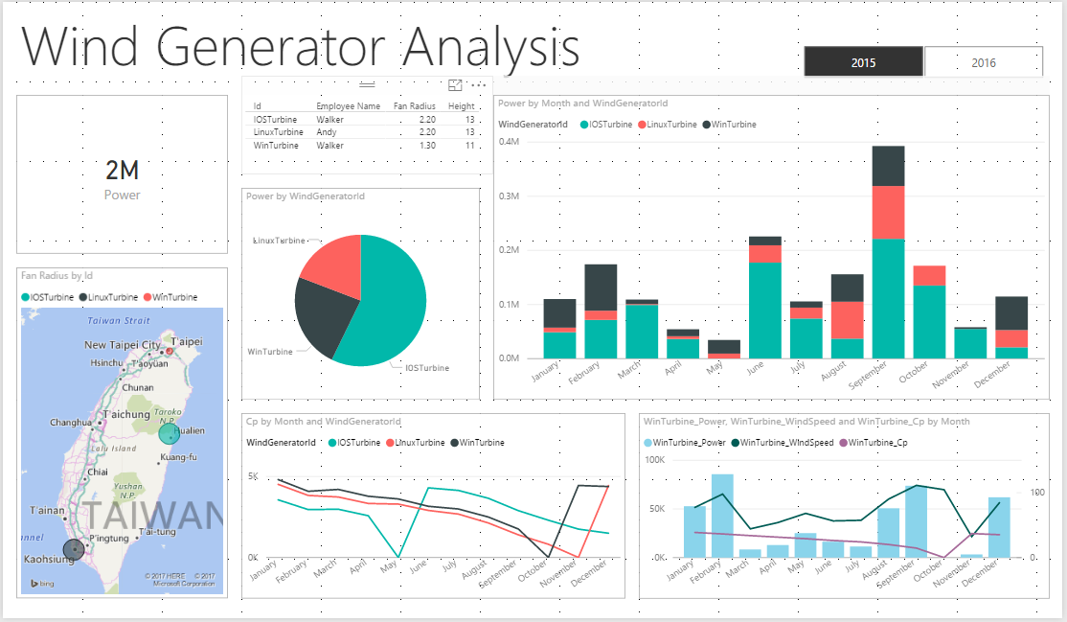

1. Click table in layout

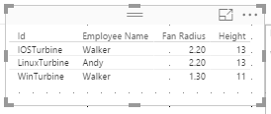

1. Switch to Format view.



1. Expand **Table style**, switch Style to **Alternation rows.**

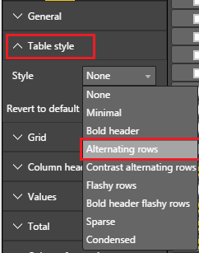

1. The final report as below picture

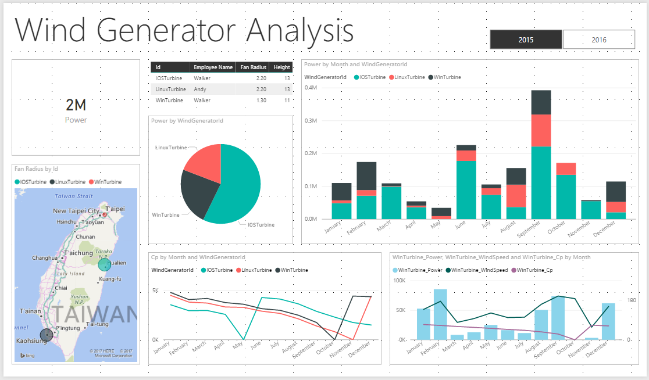

## Publish to Power BI Service

In this task, you will publish your Power BI desktop solution to Power BI service.

1. On the **Home** ribbon, from inside the **Share** group, click **Publish**.

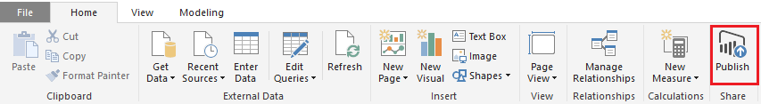

1. Sign in to your Power BI account.

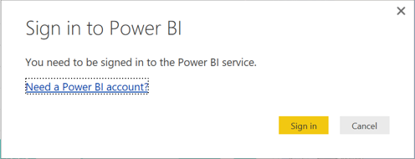

1. Successfully publish!

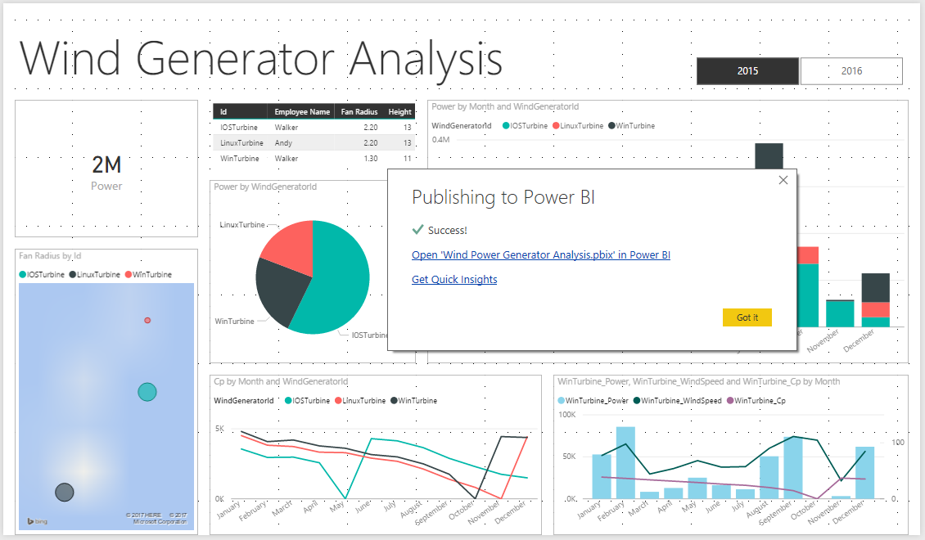

1. Click **Open ‘Wind Power Generator Analysis.pbix in Power BI**’ and then you can explore your report in Power BI service.

